Data Analysis Project for Superstore Sales Dataset
1. Project Introduction
This project focuses on processing and analyzing a dataset containing detailed information about product orders and sales. The data includes multiple elements such as order dates, shipping details, customer data, product information, and the geographical location of each purchase.
The goal of the project is to go through all stages of data analysis, starting from raw data inspection and cleaning, leading to exploratory analysis, data visualization, and extracting insights that support decision-making.

2. Team Members and Instructor
Team Members:
• Mohamad Mahmoud • Mohamad Abdelrahman
Instructor Name:
• Eng. Ahmed Samir

3. Project Phases :
- Cleaning Phase
  - Reviewing and refining raw data
  - Removing missing or illogical values
  - Standardizing formats and structures
  - Preparing data for analysis
- Pre-Analysis Questioning Phase
  - Defining key analytical questions
  - Aligning questions with overall project objectives
  - Categorizing questions by dimensions (temporal, behavioral, operational, etc.)
  - Reviewing questions to ensure clarity and non-redundancy
- Initial Analysis Phase
  - Exploring core variables
  - Identifying general trends and patterns
- Design Phase
  - Structuring the report or system layout
  - Creating prototype
  - Reviewing design with the instructor
- Final Dashboard Preparation Phase
  - Selecting final KPIs and metrics
  - Formatting visual elements
  - Configuring interactivity and filters
  - Reviewing the final dashboard before delivery

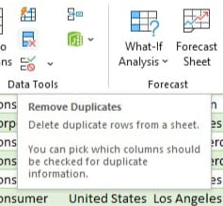
4. Data Overview
• Source: CSV file
• Number of rows: 9,800 rows
• Number of columns: 18 columns • Cleaned By Excel & Python
• Fields included in the dataset:
Order ID, Order Date, Ship Date, Ship Mode, Customer ID, Customer Name, Segment, Country, City, State, Postal Code, Region, Product ID, Category, Sub-Category, Product Name, Sales

5. Identified Issues
During the initial inspection phase, the data was checked to identify issues that could affect data quality.
• Duplicates: No duplicate rows with identical data ✅
Verification Steps:
The entire table was selected, and from the "Data" tab, "Remove Duplicates" was chosen.

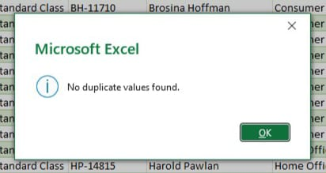

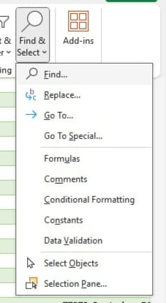
• Missing Values: 11 empty cells were found in the dataset, all located in the "Postal Code" column. Since other fields such as (Country / City / State / Region) can compensate for the postal code, the "Postal Code" column was removed ❌
Verification and Cleaning Steps:
- From "Home" tab, select "Find" and leave the search field empty
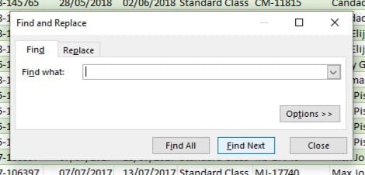
- Found 11 empty cells, all in the Postal Code column
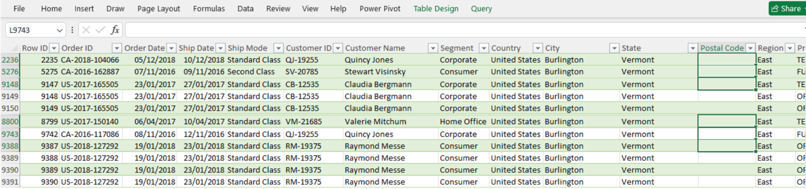
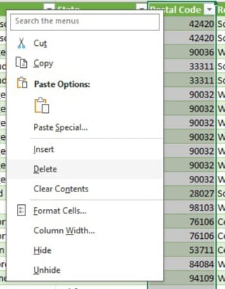
- Since other fields compensate for Postal Code, the column was selected and deleted

• Formatting: Each column was assigned a format appropriate to it’s data type ✅
Steps:
Select the entire column, then from "Format Cells", choose the suitable format
• Text Errors: No text errors found ✅

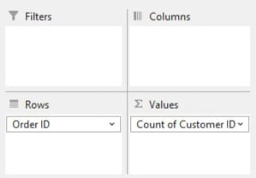
• Logical Errors:
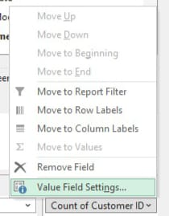
- Match between Order ID and Customer ID ✅
Verification Steps:
- Create a Pivot Table, place "Order ID" in Rows and "Customer ID" in Values
- Go to "Value Field Settings" for Customer ID and set it to "Distinct Count"
- Go to "Value Filters", choose "Greater Than", and set value to 1
- Pivot Table appears empty (if data appears, it means mismatch exists)
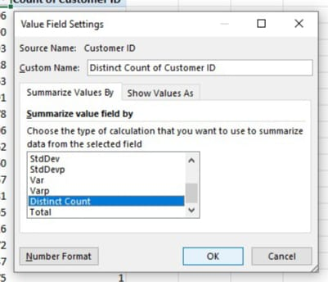
- Match between Ship Date and Order Date ✅
- Match

between Customer ID and Customer Name (and the opposite) ✅
- Match between Customer Name and Segment ✅
- Match between City and State ✅
- Match between Product ID and Category ✅
- Match between Product ID and Sub-Category ✅
- Match between Category and Sub-Category ✅
- Match between Product Name and Category ✅
- Match between Product Name and Sub-Category ✅
- Sales values are logical (no negative or zero sales) ✅
- Mismatch found between Product ID and Product Name (and the opposite) ❌
Cleaning Steps:
- Open the table for each row that appeared in the Pivot Table
- Create a Pivot Table for the new table to identify the most frequently used name
- Go to "Replace" from "Home" tab, enter the less frequent value to be replaced, and the more frequent value to replace with
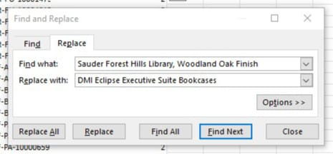
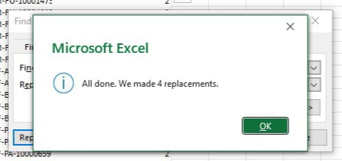
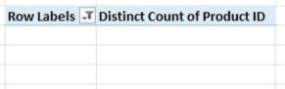
- Finally, open the Pivot Table in the main sheet to ensure it's completely empty
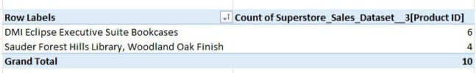
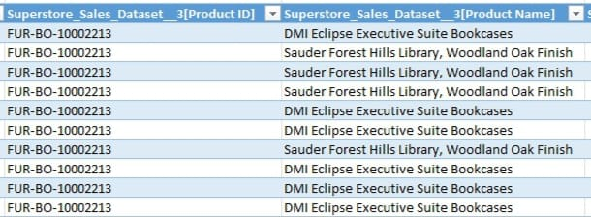
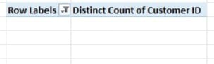
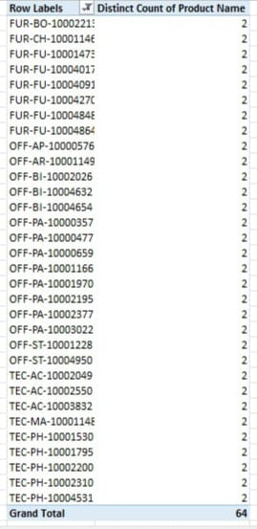
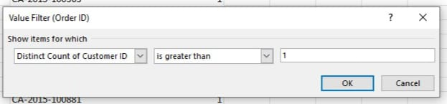
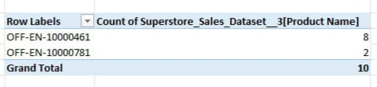
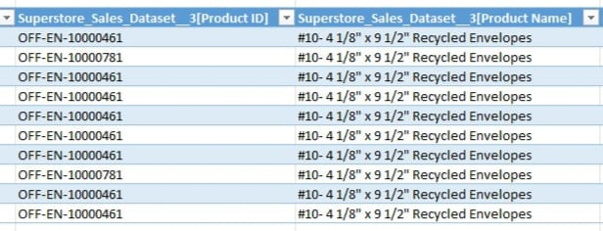
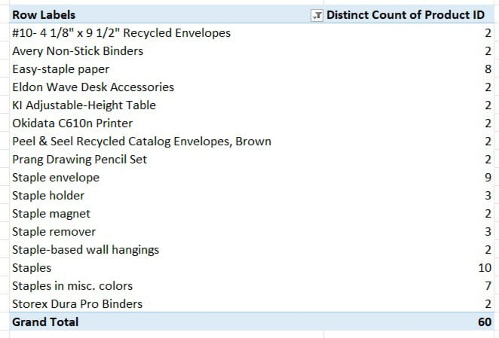

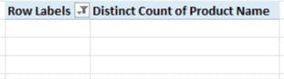
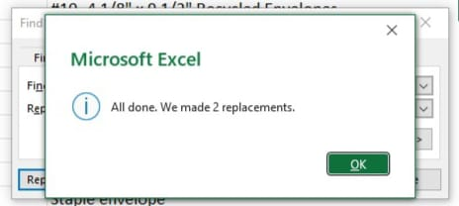
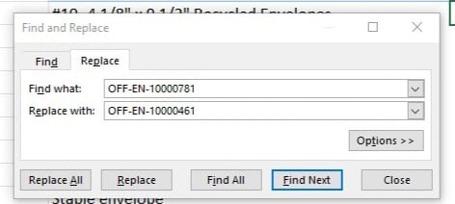

6. Creating Additional Columns
- Order Date and Ship Date can be used to calculate the difference between them and create a new column for "Shipping Duration" by the Equation =INT([@[Ship Date]]-[@[Order Date]]) to assist in upcoming statistics.
- Create “Order’s Day Of Week” Column to Mention The Day’s Name By The Equation =TEXT([@[Order Date]],"dddd") to assist in upcoming statistics.
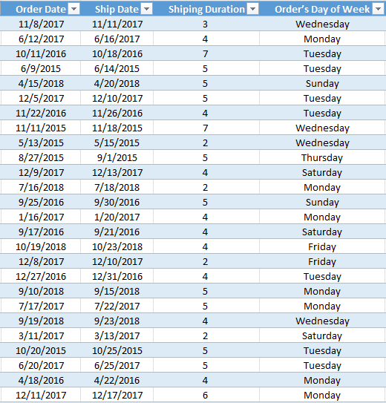

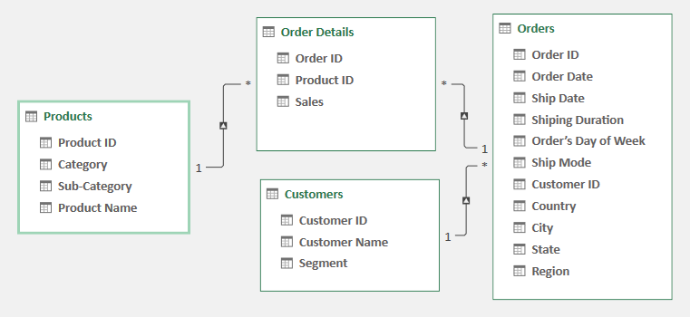
7. Database Normalization and Creating Relationships

8. Post-Cleaning Summary
• Final number of rows: 9,800 rows
• Final number of columns: 18 columns
• Number of corrected logical errors: 311 value were used incorrectly

9. Conclusion and Recommendations
The cleaning process significantly improved data quality, making it ready for analysis and accurate insight extraction.

Superstore Sales Data Cleaning Using Python
- Importing Libraries
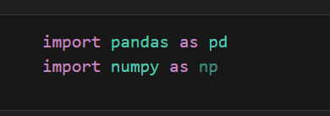
Explanation: This code imports the pandas and numpy libraries. Pandas is the core library for data manipulation and analysis, primarily through its DataFrame structure. NumPy provides support for efficient array operations and mathematical functions.
Why? These are the foundational libraries in Python for data science. They must be imported first to load the dataset, perform transformations, and carry out numerical operations throughout the cleaning process.

2. Loading the Dataset
Explanation: The pd.read_csv() function reads the specified "Superstore Sales.csv" file from your local path into memory. The data is then stored in a pandas DataFrame object named df.
Why? The dataset needs to be loaded into a structured, workable format (the DataFrame) so that pandas functions can be used to inspect, clean, and modify the data.

3. Dropping Unnecessary Columns

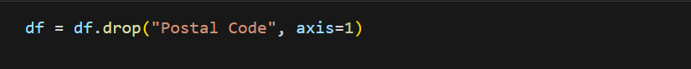
Explanation: This code uses the drop() method to remove the column named "Postal Code" from the DataFrame (df). The argument axis=1 tells pandas to look for the name in the columns, not the rows.
Why? The Postal Code provides a very granular level of geographical detail which may not be necessary if the analysis focuses on broader levels like City, State, or Region. Dropping it reduces the dataset size and simplifies the data structure without losing critical analytical information.

4. Converting Date Columns to Datetime Objects
Explanation: The pd.to_datetime() function converts the "Order Date" and "Ship Date" columns from a generic string/object type to the datetime format. - errors="coerce" converts any unparsable date strings into NaT (Not a Time/Date). - dayfirst=True informs pandas that the day appears before the month in the date string (e.g., DD/MM/YYYY).
Why? Date columns must be in the datetime format to perform time-series operations, such as calculating the difference between two dates, extracting the year or month, or grouping data by time periods.
5. Inspecting Date Conversion
Explanation: This code displays the first five rows of the "Order Date" and "Ship Date" columns.
Why? This is a quick visual quality check to ensure that the pd.to_datetime() function executed correctly and the dates are now in the proper YYYY-MM-DD format.

6. Identifying Invalid Date Logic

Explanation: A new DataFrame, wrong_dates, is created containing rows where the "Ship Date" is before or the same as the "Order Date". This filters for illogical shipping records.
Why? This is a crucial data integrity check. Logically, a product cannot be shipped before it is ordered. Identifying these erroneous records is the first step in deciding whether to correct or remove them from the dataset to maintain data quality.

7. Calculating Shipping Duration
Explanation: This code calculates the difference between the two date columns. The result is a Timedelta object, from which the .dt.days accessor extracts the number of days as an integer. This result is stored in a new feature column, shipping_duration_days.
Why? This new feature is essential for logistics and performance analysis. It allows you to calculate average shipping times, identify shipping delays, and analyze efficiency by factors like Ship Mode or Region.

8. Viewing New Feature (Shipping Duration) Explanation: The code displays the first 10 rows of the two original date columns and the newly calculated shipping_duration_days column.
Why? This is a final visual check to confirm the calculation was successful. You can quickly verify that the shipping_duration_days value correctly represents the number of days elapsed between the Order Date and the Ship Date.
9. Checking for Negative Shipping Durations
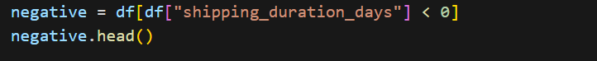
Explanation: This code attempts to find any rows where the calculated shipping duration is negative, which would mean the ship date is before the order date.
Why? A negative duration is a severe data error. Checking for this ensures that the date cleaning and calculation process did not introduce or leave behind corrupted data that would invalidate shipping time analysis. (The empty output indicates no negative durations were found.)
10 & 11. Identifying and Reviewing Product ID/Name Conflict 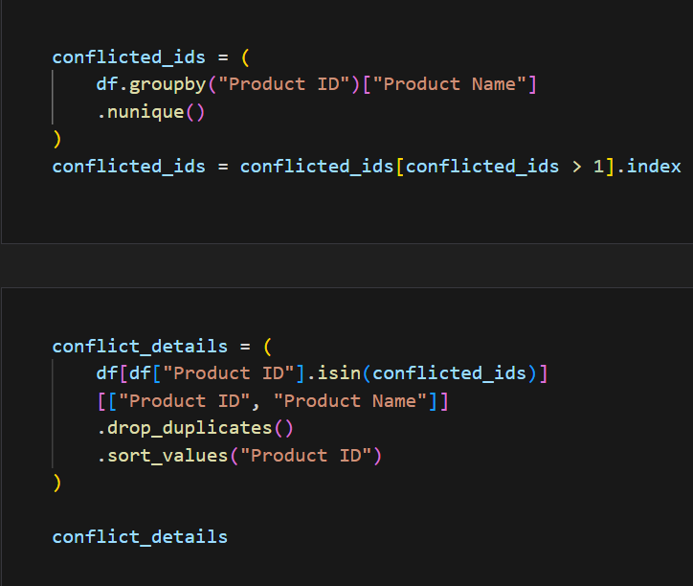
Explanation: This section identifies data conflicts where a single Product ID is associated with multiple unique Product Name values. The code first groups by Product ID, counts the unique names, and extracts the IDs with a count greater than 1. It then displays the conflicting Product ID and associated names.
Why? A Product ID should be a unique identifier for a single product. This inconsistency would lead to incorrect aggregation of sales and other metrics. Reviewing the details confirms the extent and nature of the problem before a fix is applied.
12 & 13. Resolving Product ID/Name Conflicts
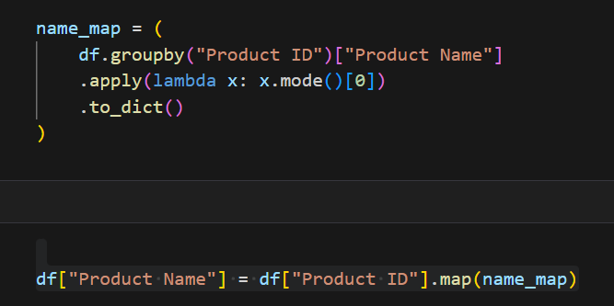
Explanation: A mapping dictionary, name_map, is created where the key is the Product ID and the value is the most frequent (mode()) Product Name for that ID. This map is then applied using the map() function to replace all existing Product Name entries with the consistent, single name associated with its Product ID.
Why? This is the correction step. By enforcing the most common name for each Product ID, all inconsistencies are resolved. This guarantees that product-level metrics (like total sales per product) are accurate.

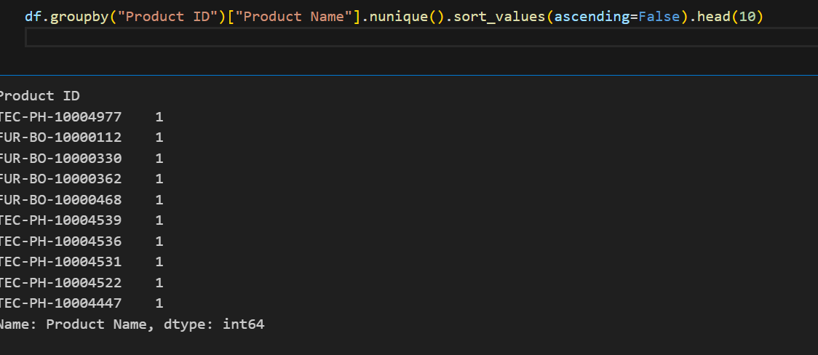
Explanation: This code is a final check to verify that the Product Name correction (using name_map) successfully eliminated all conflicts. 1. df.groupby("Product ID"): Groups the data by the unique product identifier. 2. ["Product Name"].nunique(): Counts the number of unique Product Name entries found within each Product ID group. 3. .sort_values(ascending=False).head(10): Sorts the counts from highest to lowest and displays the top 10 results.
Why? To confirm data integrity. After the fix, every Product ID must have a count of 1. If the output's top 10 results all show a count of 1, it confirms that your cleaning step was successful in standardizing product names.

Explicit Type Conversion
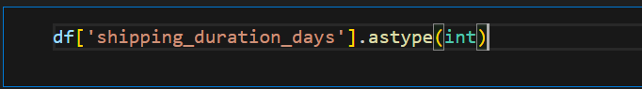
Explanation: This code explicitly converts the data type of the shipping_duration_days column to an integer type (int). While the difference between two date columns often results in an integer, this command ensures the column is formally stored as a numerical integer, not a float (which might contain decimal points) or a generic object.
Why? To optimize memory usage and ensure the column is treated correctly in numerical operations. Since shipping duration is naturally counted in whole days, an integer type is the most appropriate and efficient data format.

Rounding Sales Data
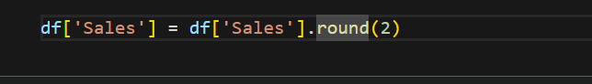
Explanation: This code uses the .round(2) method to round every value in the Sales column to two decimal places. The results are saved back into the Sales column, ensuring all sales figures have a consistent precision.
Why? To standardize the financial data. Sales figures are typically currency values, and rounding to two decimal places ensures uniformity and accurate presentation across the dataset for reporting and final analysis.

Standardizing Column Names
df.columns = df.columns.str.strip().str.lower().str.replace(' ', '_').str.replace('-', '_')

Explanation: This code cleans and standardizes all column names by chaining multiple string operations: 1. .str.strip(): Removes any leading or trailing whitespace. 2. .str.lower(): Converts all characters to lowercase. 3. .str.replace(' ', '_'): Replaces spaces with underscores. 4. .str.replace('-', '_'): Replaces hyphens with underscores. The result is reassigned back to the DataFrame's column headers.
Why? For coding efficiency and consistency. Standardized names (e.g., product_id instead of Product ID) are easier to type and prevent errors when accessing columns later in your analysis or modeling scripts

Final Data Structure Check
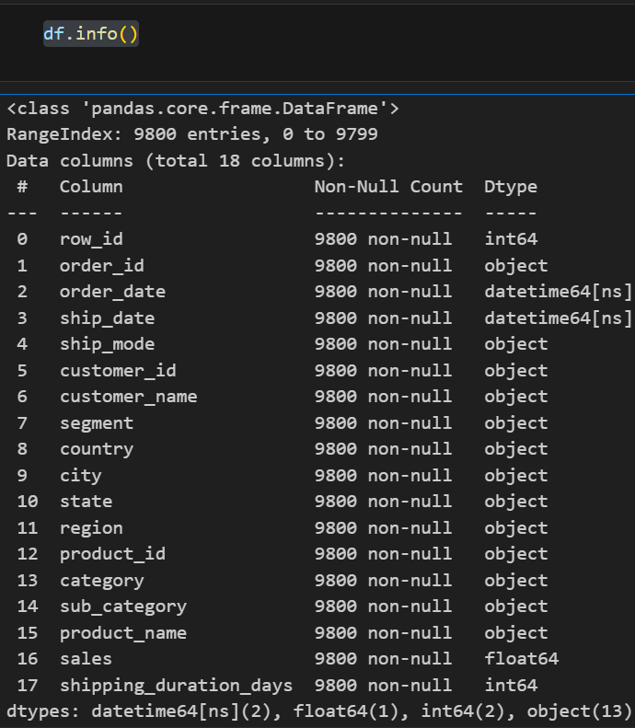
Explanation: The .info() method provides a concise, comprehensive summary of the DataFrame (df). It displays the total number of rows, the list of all columns, the non-null count for each column, and the final data type (Dtype) assigned to each column, along with memory usage.
Why? This is the final data integrity check. It confirms that: 1) all date/numerical/object columns have the expected final data types after conversion, and 2) there are zero unexpected missing values (Non-Null Count equals Total Entries) before the final clean dataset is saved.

Saving the Cleaned Dataset
df.to_csv("C:\\Users\\ACCESS\\Documents\\event-management\\Superstore Sales.csv", index=False)
Explanation: This code executes the .to_csv() method to save the final, cleaned, and standardized DataFrame (df) back to a CSV file. 1. File Path: Specifies the exact location and name where the file should be saved (overwriting the original data). 2. index=False: This crucial argument instructs pandas not to write the DataFrame's row indices as an extra, unnecessary column in the output CSV file.
Why? To finalize the project step. All cleaning and transformation efforts are now locked in, creating a high-quality, reliable, and consistent dataset ready for advanced analysis, visualization, and modeling.

Analysis Phase
1-Overview Analysis
1. Key Performance Indicators (KPIs):
- Question: What is the high-level summary of the business performance?
- Visualization: Creating Scorecards to display the Total Sales, Total Orders, Total Customers, and Average Order Value to give a quick snapshot of the business health.

2. Quarterly Orders Trend:
- Question: How has the volume of orders changed over time on a quarterly basis?
- Visualization: Creating a Line Chart showing the trend of order counts from 2015 to 2018, and adding a Reference Line to compare the quarterly performance against the overall average.
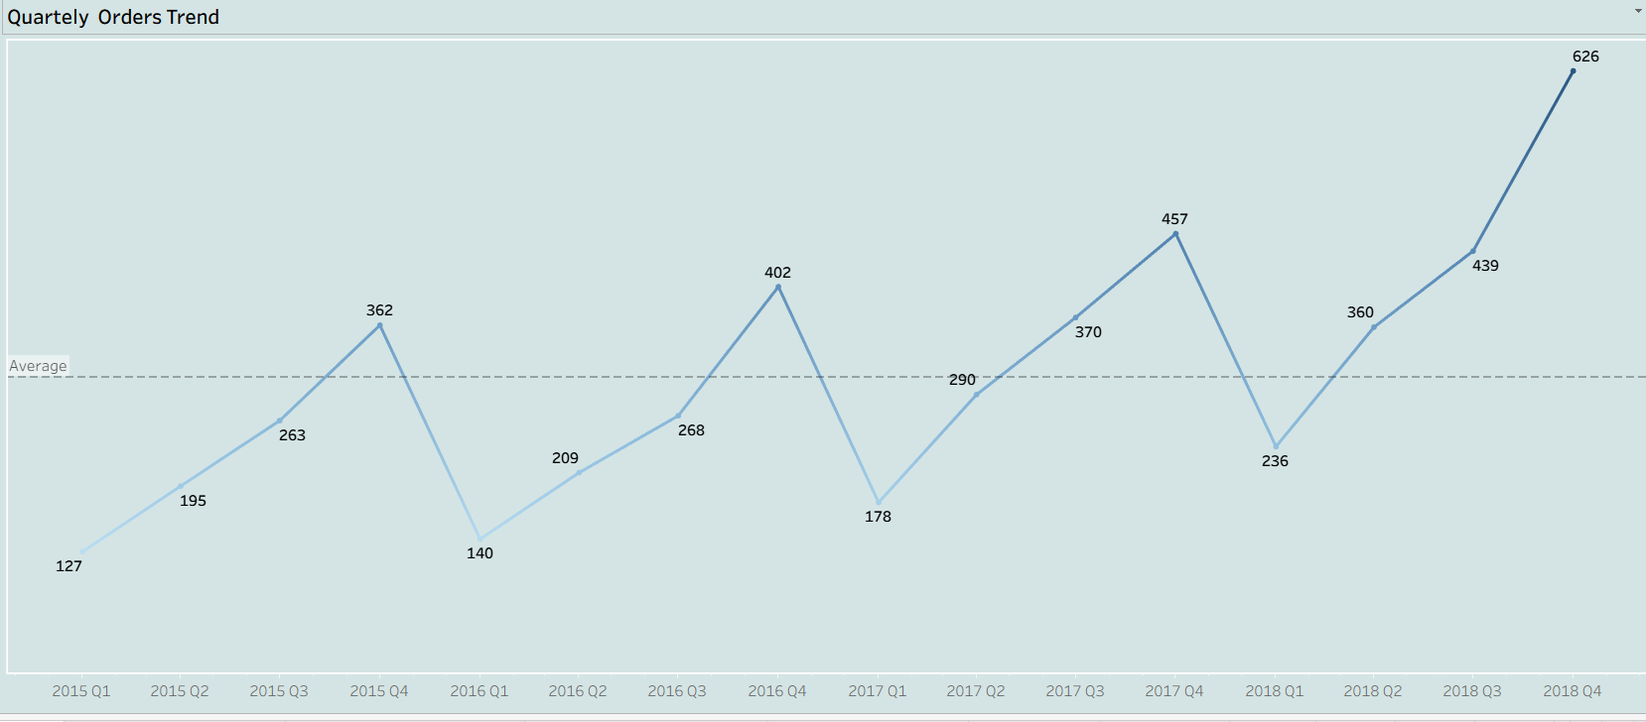

3. Order Distribution by Region:
- Question: Which regions contribute the most to the total order volume?
- Visualization: Creating a Packed Bubble Chart to visualize the percentage distribution of orders across different regions (West, East, Central, South).

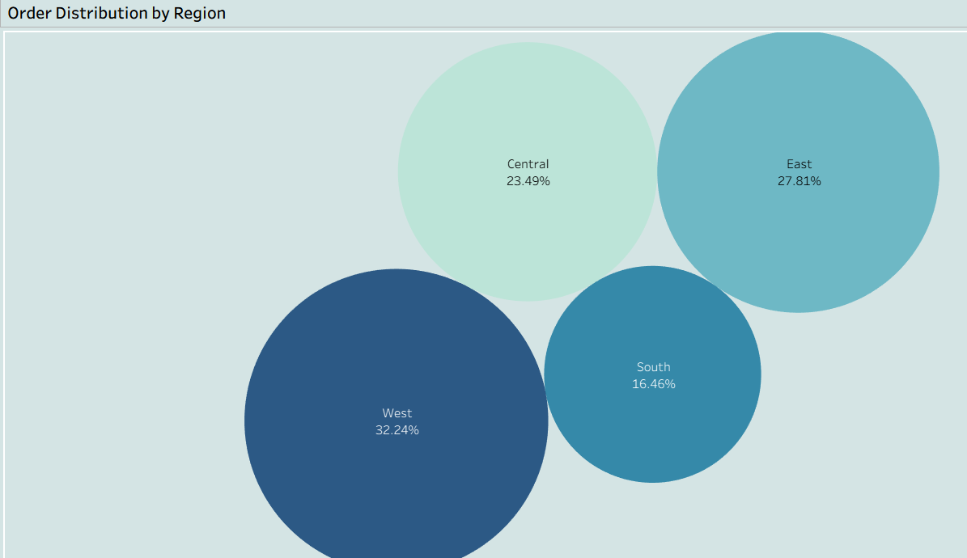

4. Top 3 Performing States:
- Question: Which geographical states have the highest performance?
- Visualization: Creating a Map highlighting the Top 3 states based on order volume to identify key geographical markets.
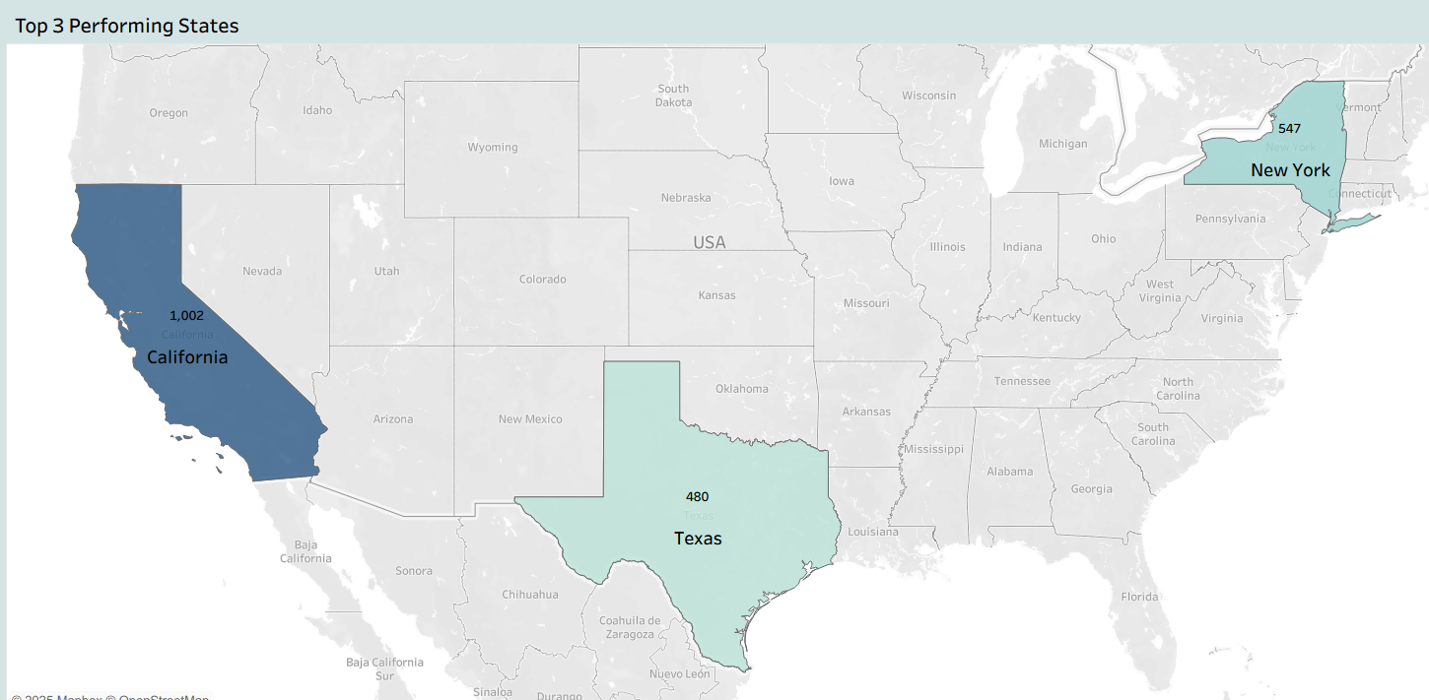
5. Top 10 Cities by Order Volume:
- Question: Which specific cities are generating the most orders?
- Visualization: Creating a Bar Chart that ranks the top 10 cities by order count, sorted in descending order to identify the most active urban areas.
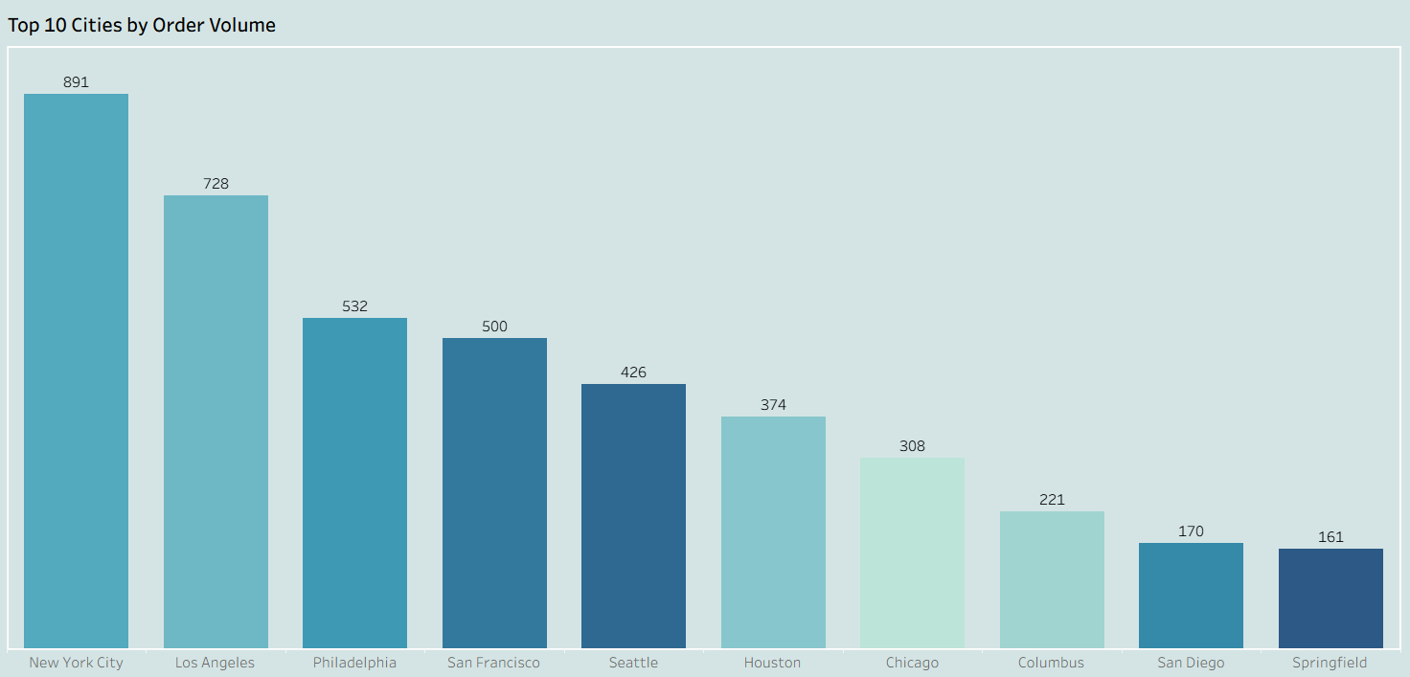
6. Orders Percentage by Category:
- Question: How are orders distributed across the main product categories?
- Visualization: Creating a Pie Chart to show the market share percentage of Office Supplies, Furniture, and Technology categories.
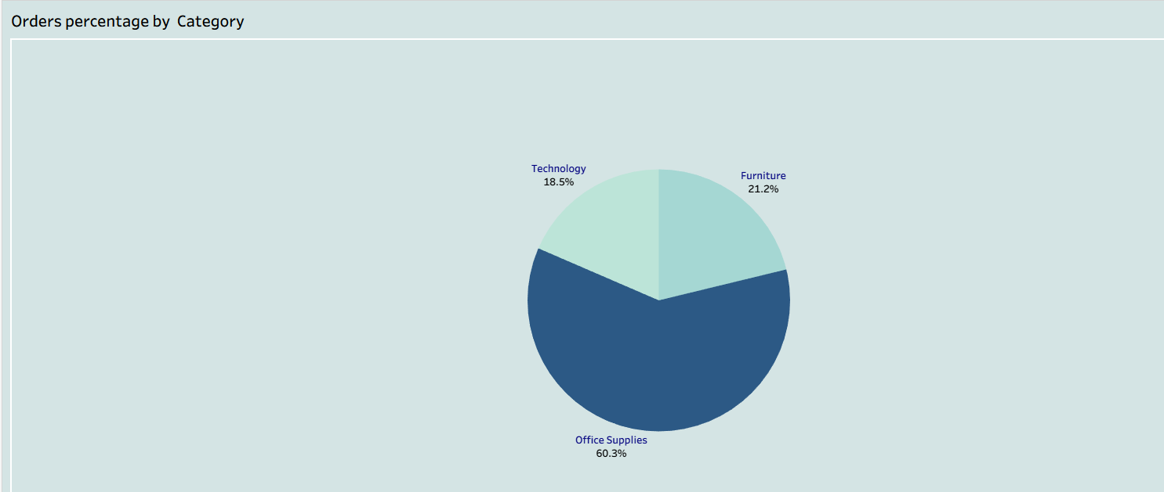
Final Dashboard
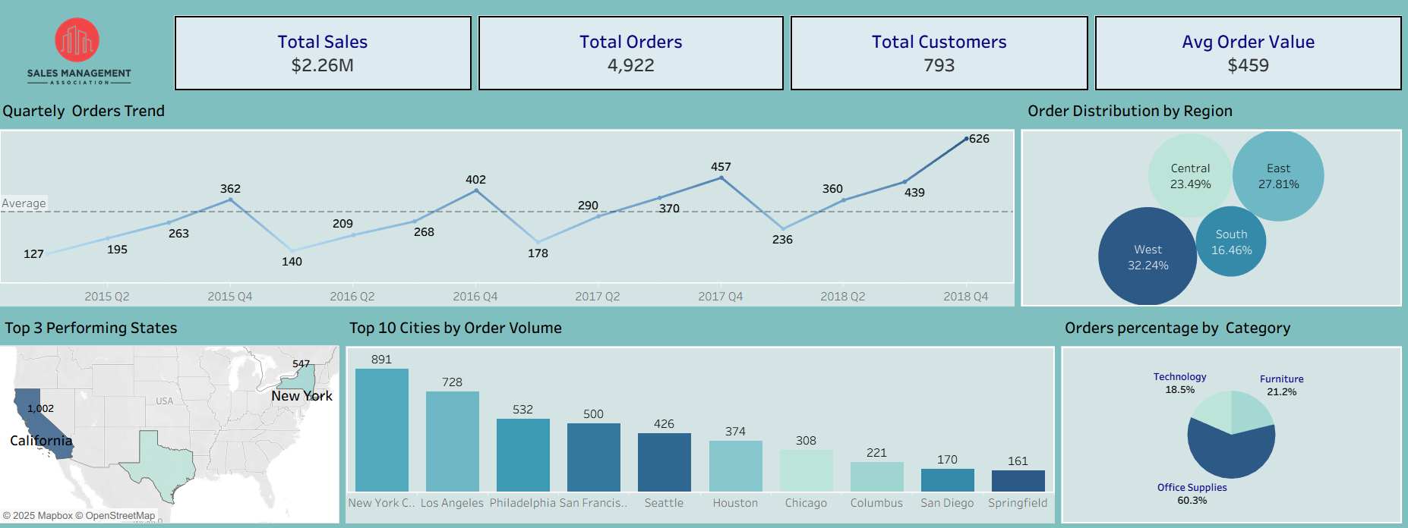
- After Choosing The Design And Adding a Suitable Title & Logo, Creating The Main KPI Cards, Adding The Quarterly Timeline, Making The Region & Map Charts As Filters And Putting The Parameters.

② Sales Analysis:

1. Sales During Week:
- Question: How do Sales Vary Across Different Week Days?
- Visualization: Creating a Line Chart That Shows Sales In Each Week Day

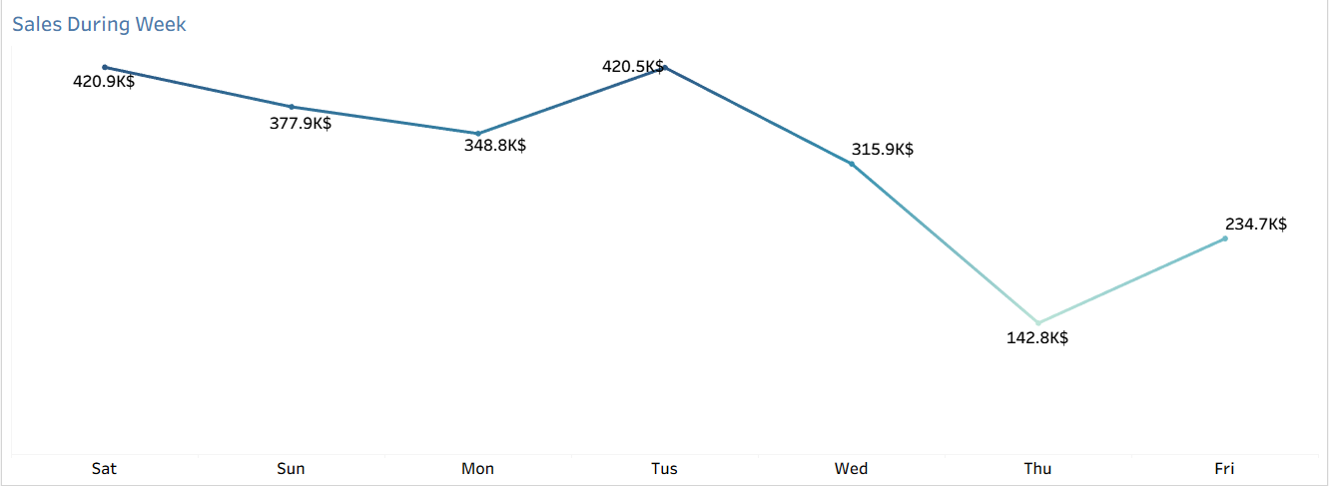

2. % Of Sales By Categories:
- Question: How Do % Sales Vary Across Different Categories?
- Visualization: Creating a Pie Chart That Shows The % For Each Categories

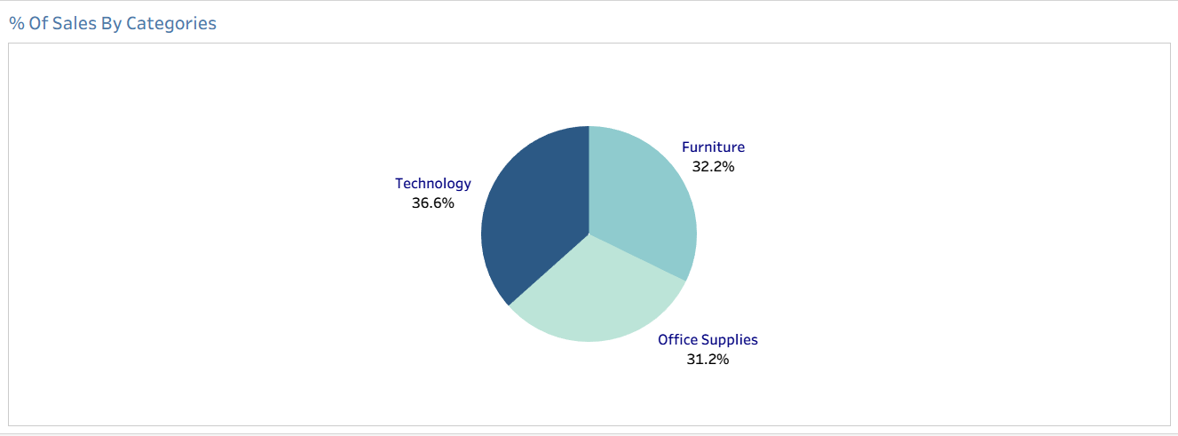

3. Sales By Top & Bottom Sub-Categories:
- Question: What Are The Top & Bottom Sub-Categories?
- Visualization: Creating a Column Chart That Shows Sales For Top 5 Sub-Categories. And Using a Parameter To Switch To The Bottom 5

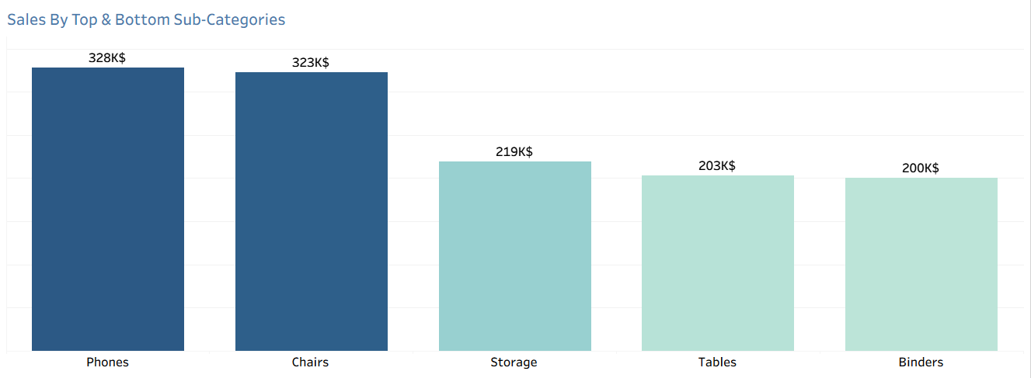

4. Top & Bottom Sales Products:
- Question: What Are The Top & Bottom Sub-Categories?
- Visualization: Creating a Bar Chart That Shows Sales For Top 5 Products. And Using a Parameter To Switch To The Bottom 5

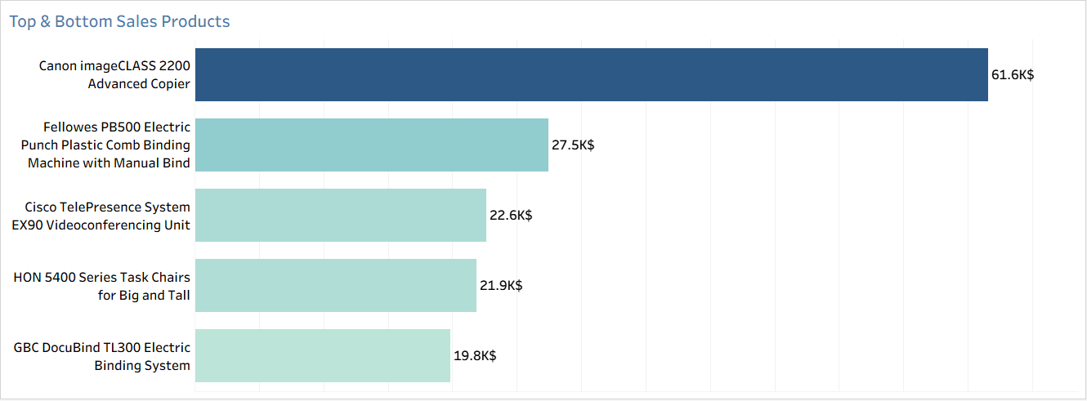

5. Sales Per Month:
- Question: How Do % Sales Vary Across Different Times?
- Visualization: Creating a Line Chart That Shows Sales In Each Time Point

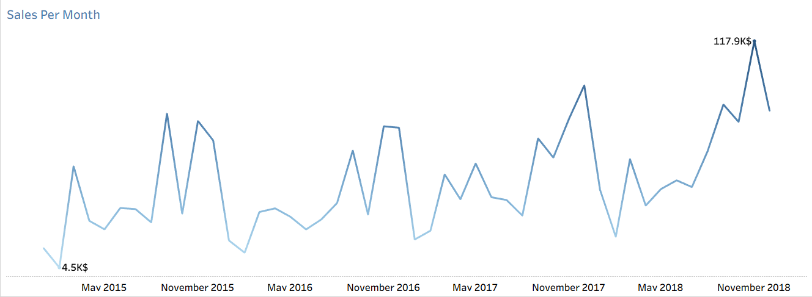

6. Top & Bottom Profitable Customers:
- Question: Who Are The Top & Bottom Profitable Customers?
- Visualization: Creating a Bar Chart That Shows Sales For Top 5 Customers. And Using a Parameter To Switch To The Bottom 5

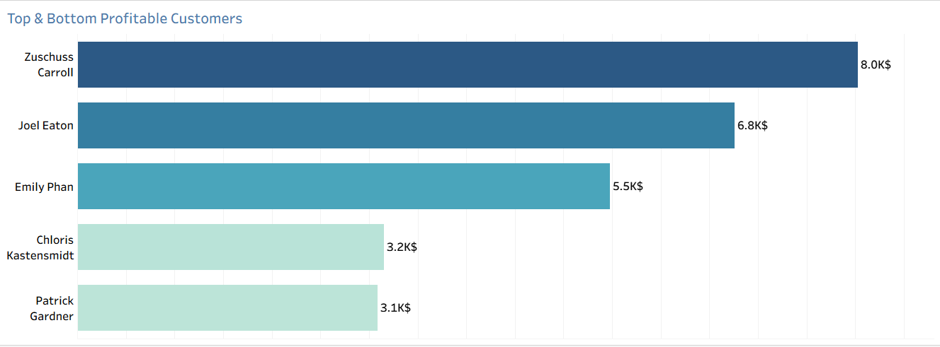

7. % Of Sales By Shipping Modes:
- Question: How Do % Of Sales Vary Across different Shipping Modes?
- Visualization: Creating a TreeMap Chart That Shows The % Of Sales In Each Shipping Mode

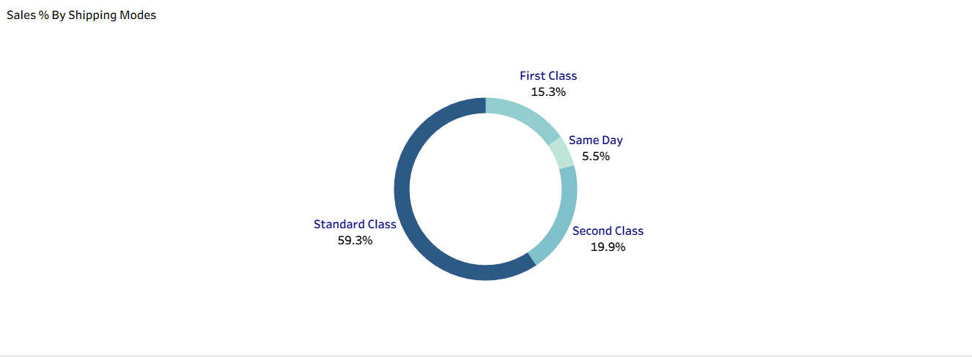

Final Dashboard
- After Choosing The Design And Adding a Suitable Title & Logo , “Total Sales” Card , Timelines , Making Some Charts As Filters And Putting The Parameters
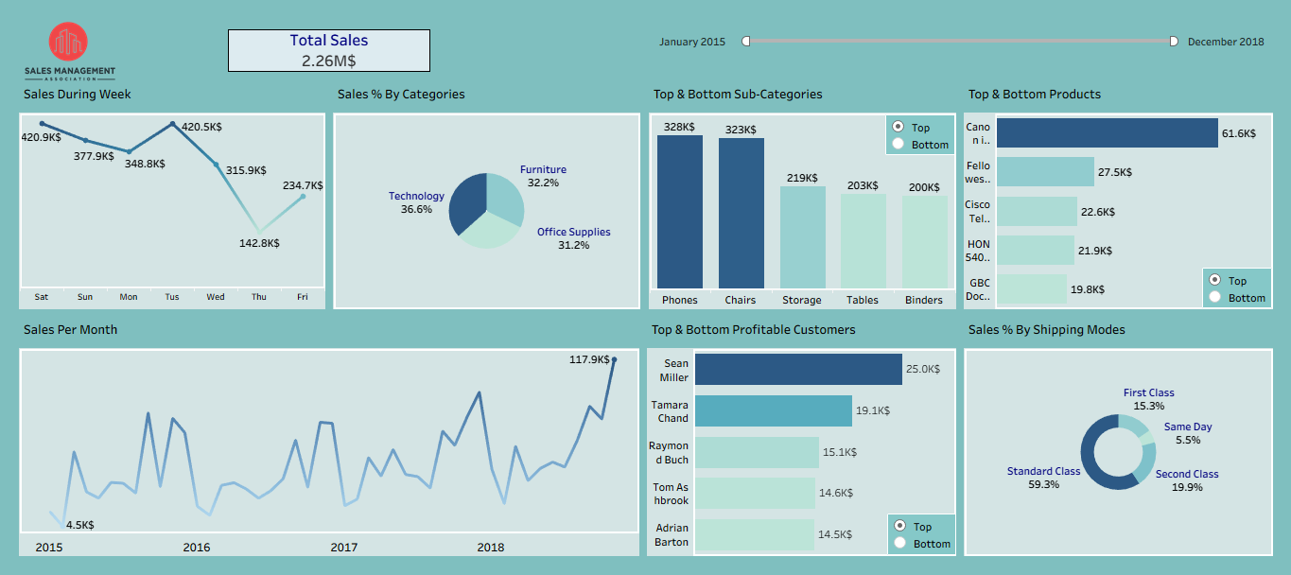

③ Products Analysis:

1. % Of Categories By Sales:
- Question: How Do % Of Sales Vary Across Different Categories?
- Visualization: Creating a Donut Chart That Shows The Sales % For Each Categories
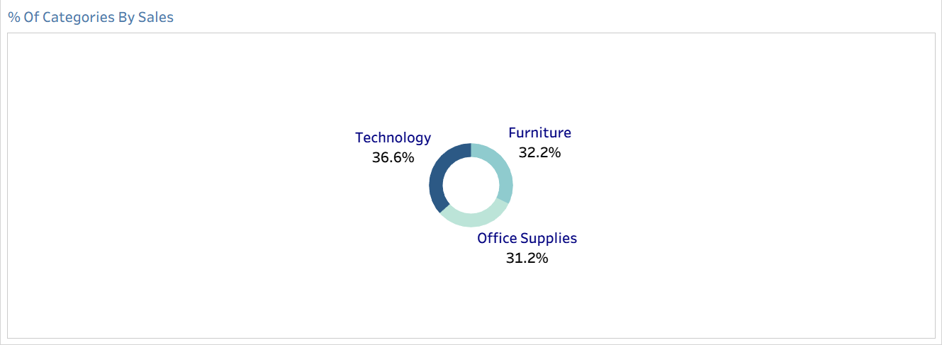

2. % Of Categories By Orders:
- Question: How Do % Of Orders Vary Across Different Categories?
- Visualization: Creating a Pie Chart That Shows The Orders % For Each Categories



3. Top & Bottom Sub-Categories By Sales:
- Question: What Are The Top & Bottom Sub-Categories?
- Visualization: Creating a Column Chart That Shows Sales For Top 5 Sub-Categories. And Using a Parameter To Switch To The Bottom 5
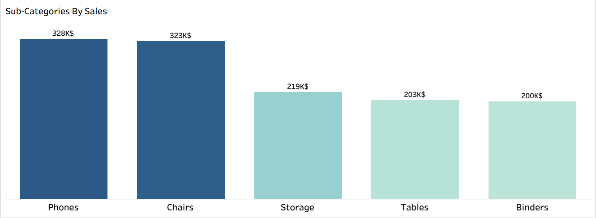

4. Top & Bottom Sub-Categories By Orders:
- Question: What Are The Top & Bottom Sub-Categories?
- Visualization: Creating a Column Chart That Shows Orders For Top 5 Sub-Categories. And Using a Parameter To Switch To The Bottom 5

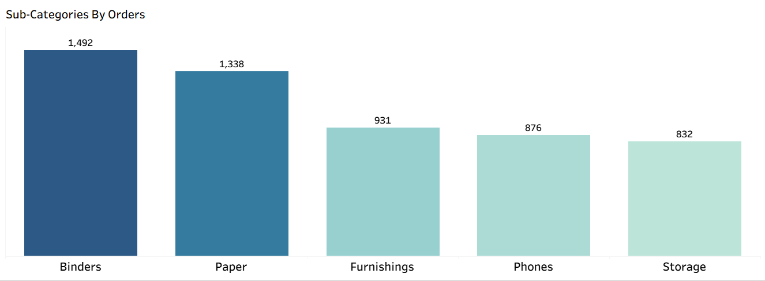

5. Top & Bottom Products By Sales:
- Question: What Are The Top & Bottom Products?
- Visualization: Creating a Column Chart That Shows Sales For Top 5 Products. And Using a Parameter To Switch To The Bottom 5
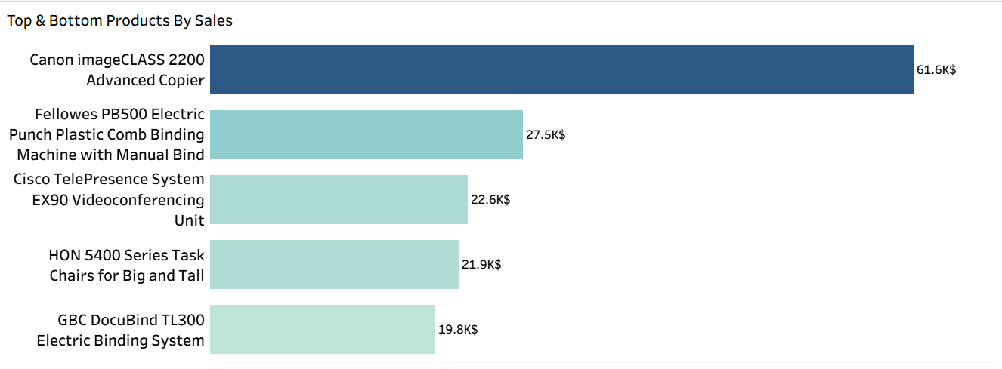

6. Top & Bottom Products By Orders:
- Question: What Are The Top & Bottom Products?
- Visualization: Creating a Column Chart That Shows Orders For Top 5 Products. And Using a Parameter To Switch To The Bottom 5
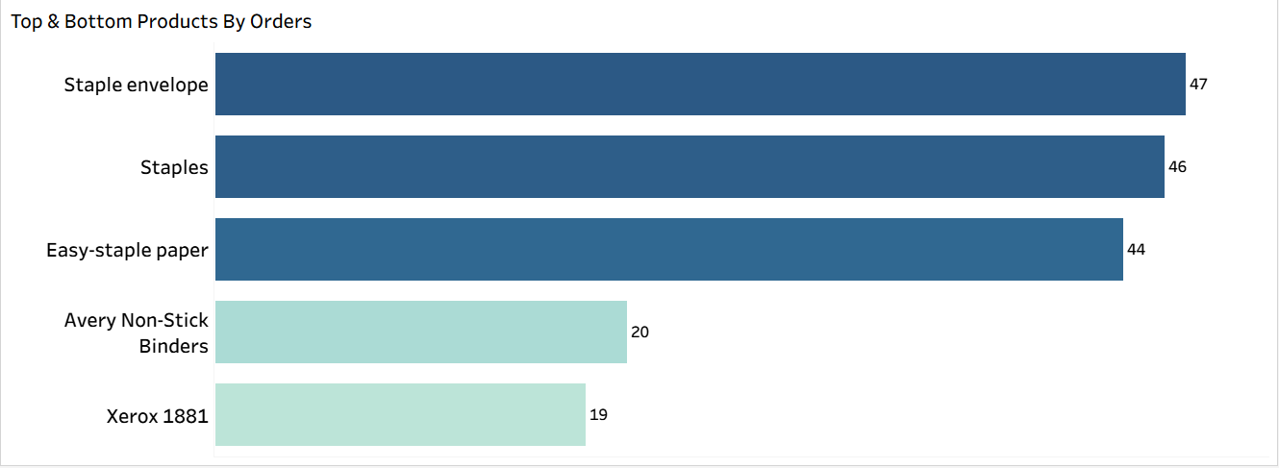

Final Dashboard
- After Choosing The Design And Adding a Suitable Title & Logo , “# Of Products” Card , Timelines , Making Some Charts As Filters And Putting The Parameters
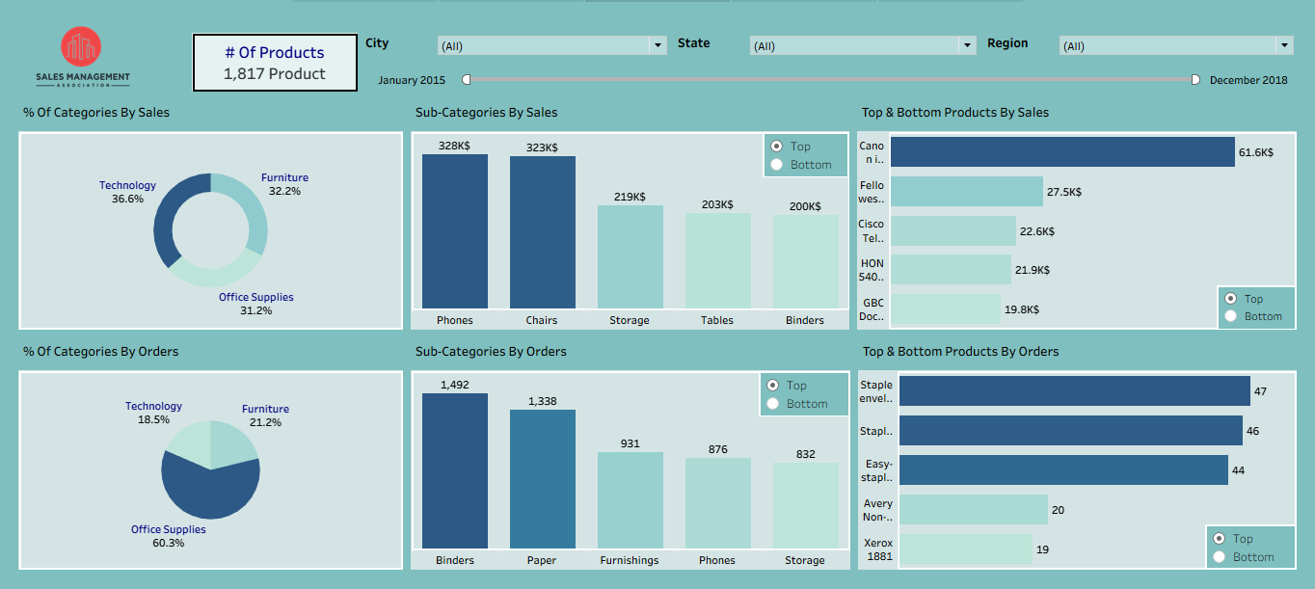

④Customers Analysis:

1. Top & Bottom Profitable Customers:
- Question: What Are The Top & Bottom Profitable Customers?
- Visualization: Creating a Bar Chart That Shows Sales For Top 5 Customers. And Using a Parameter To Switch To The Bottom 5
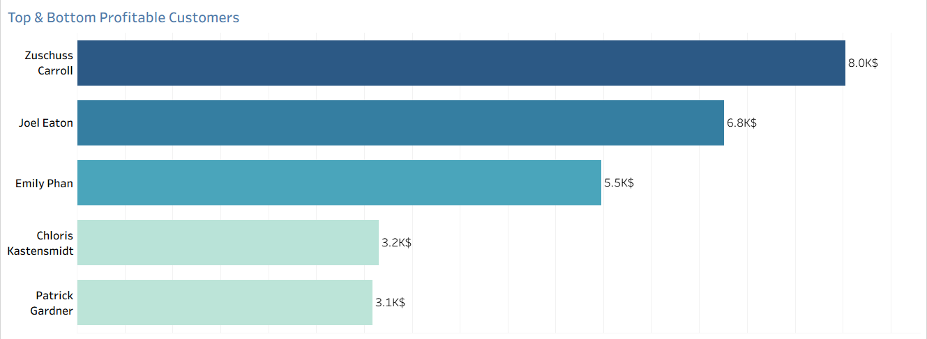

2. Top & Bottom Loyal Customers:
- Question: What Are The Top & Bottom Loyal Customers?
- Visualization: Creating a Bar Chart That Shows Total Orders For Top 5 Customers. And Using a Parameter To Switch To The Bottom 5

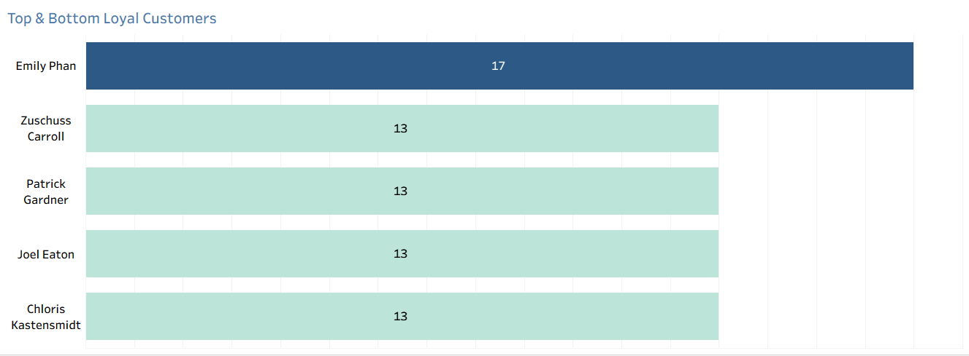

3. % Of Customers By Segment:
- Question: How Do % Of Customers Vary Across Different Segmants?
- Visualization: Creating a Pie Chart That Shows The Customers % For Each Segmant

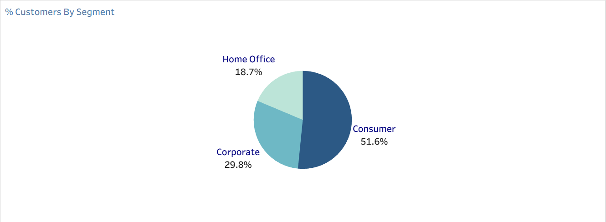

4. % Of Segment By Sales:
- Question: How Do % Of Sales Vary Across Different Segmants?
- Visualization: Creating a Donut Chart That Shows The Sales % For Each Segmant

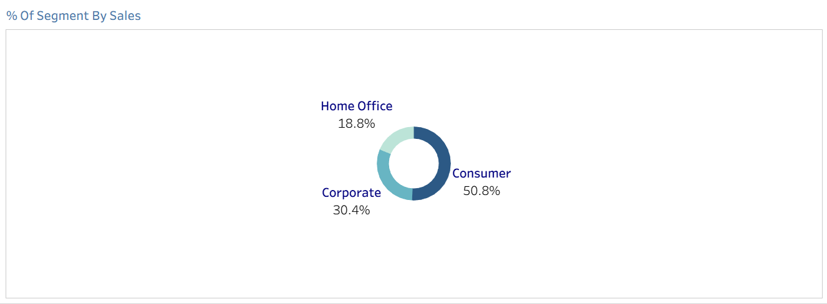

Final Dashboard
- After Adding a Suitable Title & Logo , “# Of Customers” , Timelines , Putting Category Filter & Making Some Charts As Filters And Putting The Parameters
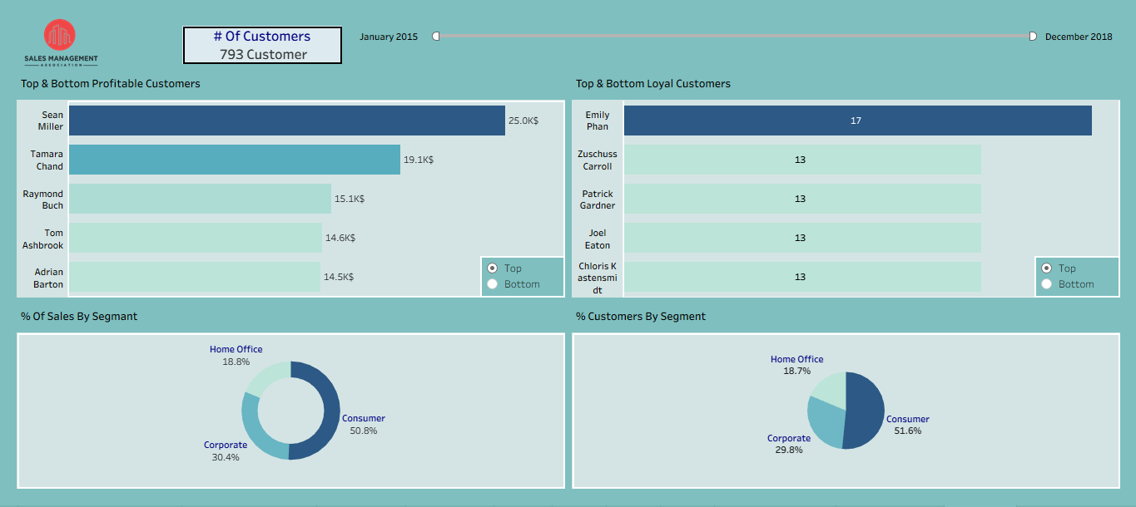
5-Shipping & Delivery Analysis
1. Key Performance Indicators (KPIs):
- Question: What are the main indicators of shipping performance?
- Visualization: Creating Scorecards to show On-Time Rate, Delay Rate, and Average Delivery Days to evaluate logistics efficiency.
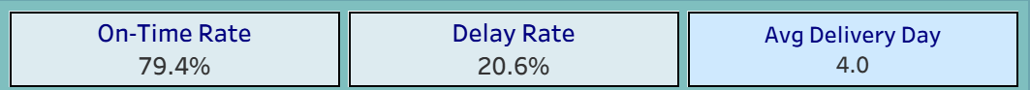

2. Delivery Days Distribution:
- Question: How long does it typically take to deliver an order?
- Visualization: Creating a Histogram to display the distribution of shipping duration (in days) and identify the most common delivery times.
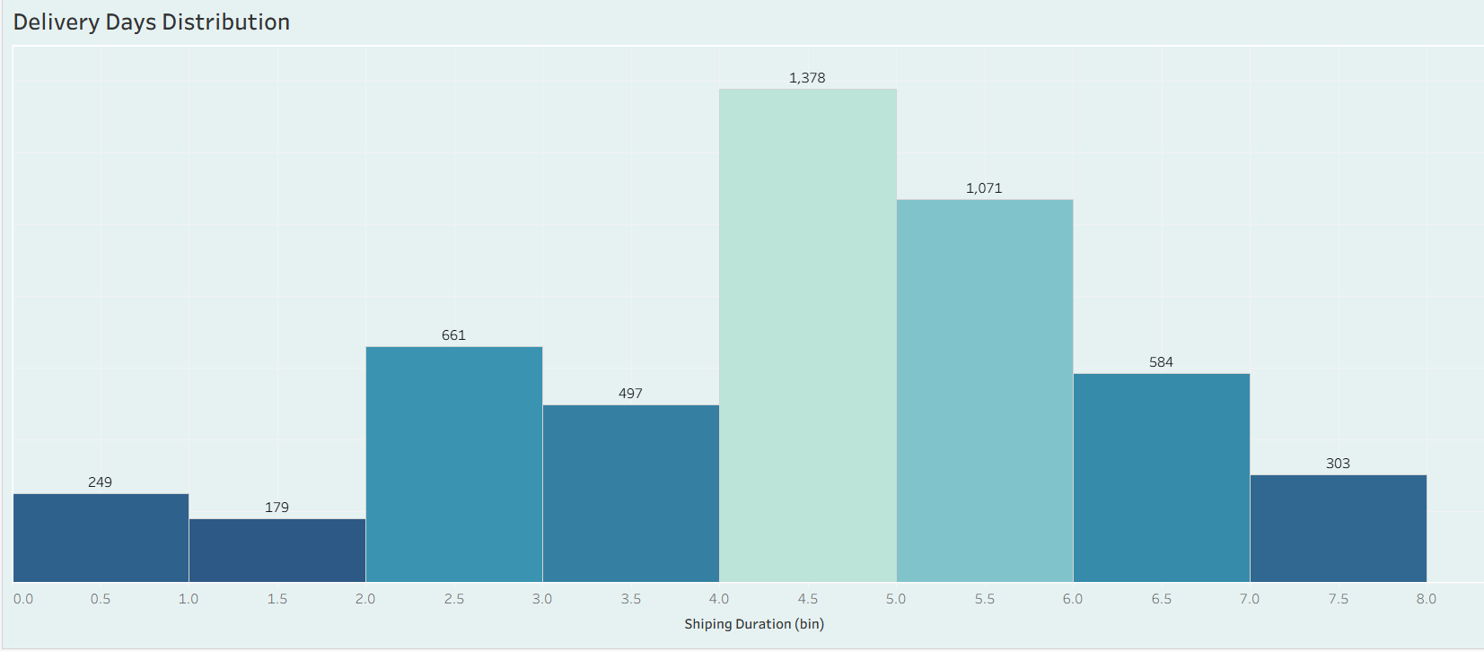

3. Avg Delivery Time by Ship Mode:
- Question: How does the shipping mode affect the delivery speed?
- Visualization: Creating a Bar Chart comparing the average delivery days across Standard, Second, First, and Same Day shipping modes.
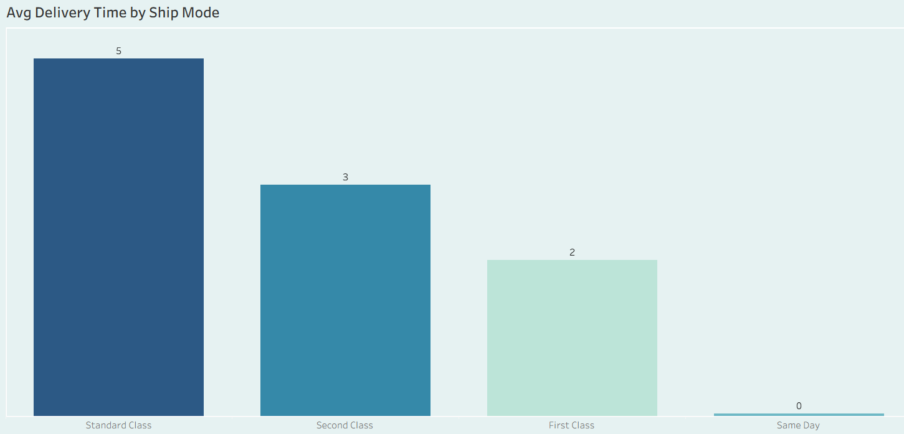
4. On-Time vs Delay by Ship Mode:
- Question: Which shipping modes have the highest rate of delayed orders?
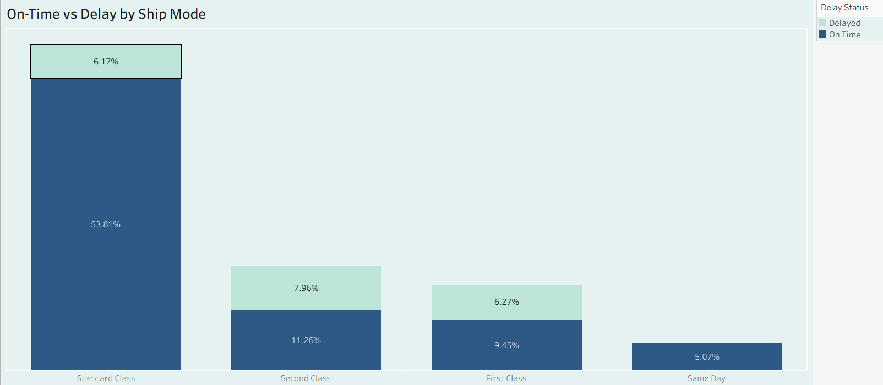
- Visualization: Creating a Stacked Bar Chart to analyze the proportion of On-Time versus Delayed orders for each shipping mode.

5. Revenue Share by Delivery Status:
- Question: How much revenue is impacted by delayed deliveries?
- Visualization: Creating a Pie Chart to visualize the percentage of total revenue generated from On-Time versus Delayed orders.
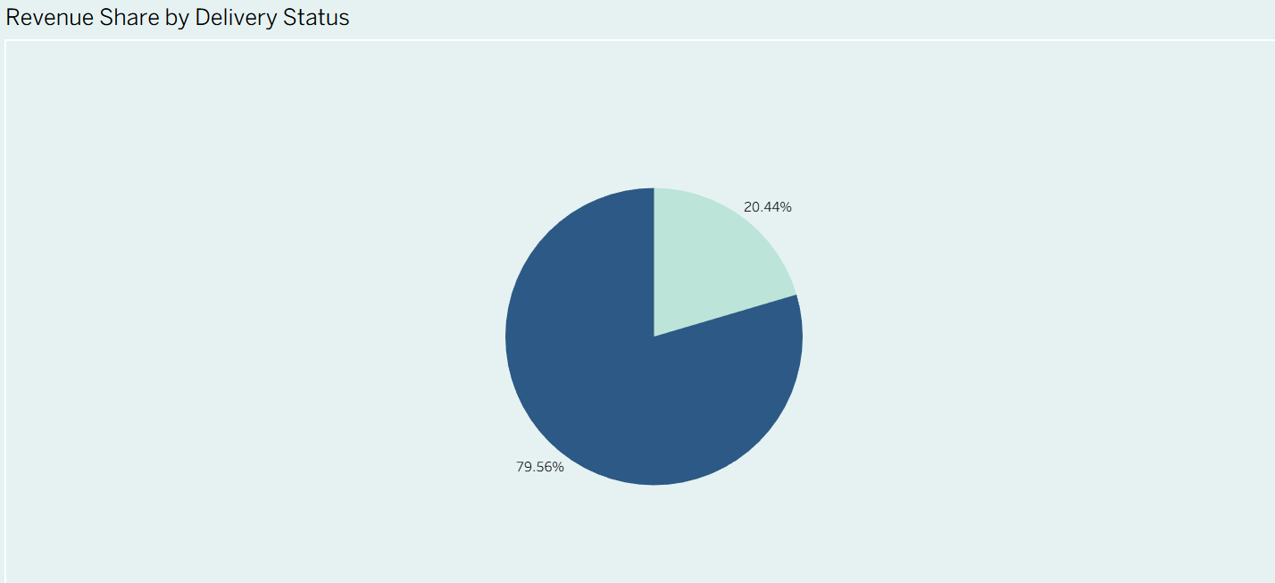
6. AVG Delivery Time by Region:
- Question: Is there a variation in delivery speed across different regions?
- Visualization: Creating a Packed Bubble Chart to compare the average delivery time in the West, East, Central, and South regions.
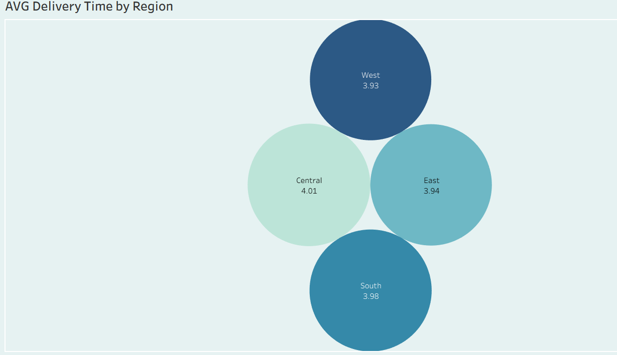

Final Dashboard
- After Adding a Suitable Title & Logo, Creating The Shipping KPI Cards, Analyzing Delivery Trends With Histograms, Making The Ship Mode Charts As Filters And Putting The Parameters.
